R-squared and adjusted R-squared

R-squared - It tells you how much of the variation in your dependent variable (what you are trying to predict) can be explained by your independent variables (your data).
It is formally known as the Coefficient of Determination.

1. The Core Concept
Imagine you are trying to predict Weight based on Height.
- People have different weights (this is the total variation).
- Some of that difference is because people have different heights.
- Some of that difference is due to other things (diet, muscle mass, genetics).
R-square tells you exactly what percentage of those weight differences is explained by height alone. If R-square is 0.70, it means height explains 70% of the variation in weight. The remaining 30% is "noise" or unexplained factors.

. The Scale: 0 to 1
R-squared is almost always expressed as a value between 0 and 1 (or 0% to 100%).
- 0: The model explains none of the variability of the response data around its mean. (The model is useless).
- 1: The model explains all the variability. (The model is perfect; every data point falls exactly on the regression line).

3. How it is Calculated
To calculate R-squared, we compare two things:
- The Error in your model: How far the actual data points are from your regression line (Sum of Squares Residuals).
- The Total Variation: How far the data points are from the simple average/mean (Total Sum of Squares).
R^2 also known as coefficient of determination
SSR = sum of squares of residuals
SST = total sum of squares



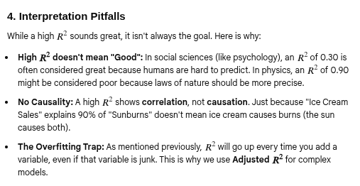

~

You first have to look at the limitation of the standard R-squared:
- The Problem: If you are trying to predict house prices and you add "the number of clouds in the sky" as a variable,
might slightly increase just by random chance. This can lead to overfitting, where the model looks great on paper but fails in the real world.
- The Solution: Adjusted R-squared only increases if the new variable improves the model more than would be expected by chance. If you add a useless variable, the Adjusted R-squared will actually decrease.

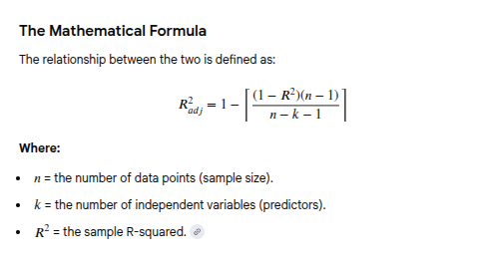
1

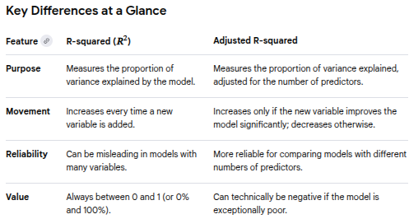
~

When should you use it?
You should focus on Adjusted R-squared whenever you are doing Multiple Linear Regression (using more than one independent variable). It is the best tool for "feature selection"—helping you decide if adding that extra piece of data is actually making your model smarter or just more cluttered.

